11th AFRICA-EUROPE Training Course
for Youth Organisations

To be held between 8-15 November 2015
Nairobi, Kenya

In the framework of the 7th African University on Youth and Development

DEADLINE 12th October 2015

In partnership with:

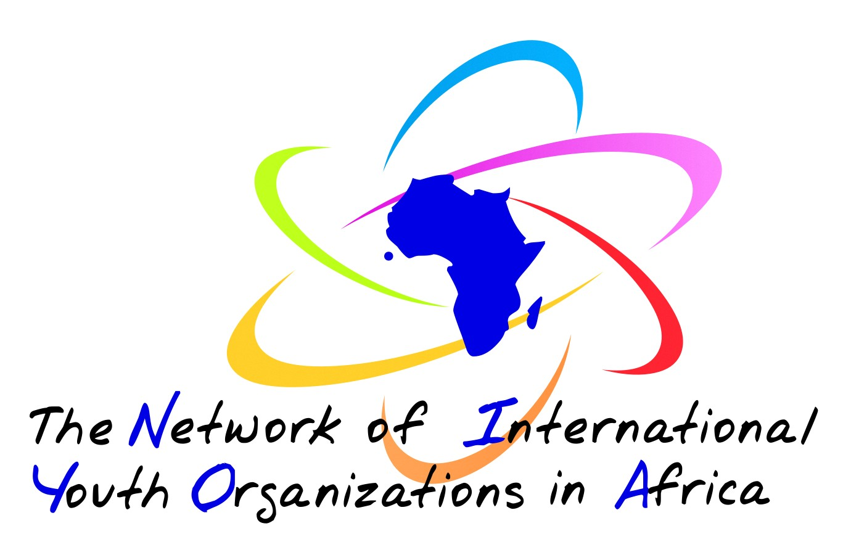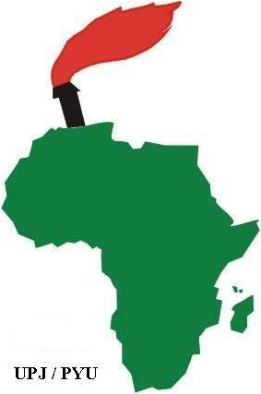

APPLICATION FORM

Please type or write legibly. If necessary, please attach an extra sheet.

I. INFORMATION ABOUT THE APPLICANT
- Personal Information:
Name:

Sex: Male Female Age: Nationality:
- Working languages:
English French
- Contacts – Please note that all correspondence will be sent to this address, so please ensure it is complete.

Postal address (street, number, city, postal code, country):
Telephone: Telefax:
Mobile telephone: E-mail:

II. INFORMATION ABOUT THE ORGANISATION
- Sending organisation or institution
Name:
Postal address:
Telephone: Telefax:
E-mail: Internet address:

- How would you best describe your sending organisation? (multiple answers possible)

an international youth organisation a national youth council (name):
a national youth organisation a local/regional youth organisation
a development NGO a governmental institution
a minority or minority rights association
other (please specify):
- What is your role/responsibility within your organisation?
volunteer employee board member (elected)
active member civil servant other (please specify):
- In what capacity are you involved in youth work?
full-time youth worker trainer of youth workers or youth leaders
volunteer youth worker occasional youth worker
teacher leader of a youth group or association
other (please specify)

III. BACKGROUND AND MOTIVATIONS

- Why does your organisation want to take part in the Africa-Europe Training Course?

- Please describe briefly the past experience and future plans of your organisation in the Africa-Europe Youth Co-operation.

- Please describe your role and position in your organisation.

- What is your personal motivation to participate in the event?

- Have you applied for, or attended, any other training course of the North-South Centre or the Youth Department of the Council of Europe? If so, please give details.

IV. ADMNISTRATIVE AND LOGISICAL ARRANGEMENTS

- Have you any special needs or requirements? (e.g. dietary, mobility, etc.)

- Visas
If you are accepted as a participant on this course, will you require assistance in obtaining a Visa for Kenya?
No Yes
If yes, please indicate:
Date of birth: Passport No.: Issued at (place and date):
Place of birth: Date of expiry:
- Plane ticket, from airport of departure to Nairobi, Kenya (the NSC will do it’s best to arrange a pre-paid ticket, please do not proceed with any booking)

Airport of departure:
Price of your ticket: Euros

Date: Signature:

Send your application form and recommendation letter to:

nsc.africaeurope-youthsummit@coe.int

DEADLINE: 12th October 2015 – 23:59 pm (GMT+1)

